**Vadodar**

**Dat**



Python Programming

**(DI01016011)**

LABORATORY MANUAL

**Diploma. Semester-I**

**Prepared By:- CE/IT Department**

**Vadodara Institute of Engineering (903) Kotambi, Vadodara – 391510**

**Academic Year : 2025-2026**

# Index

|  |  |
| --- | --- |
| **Sr No** | **Practicals** |
| **1** | Prepare flowchart and algorithm for a given problem.  ● Find the sum of two given numbers.  ● Find a maximum out of two given numbers.  ● Find whether a given number is odd or even.  ● Find a maximum out of three given numbers. |
| **2** | Install & configure python software and Create a program to print your name, date of birth and mobile number. |
| **3** | Develop a program to identify data-types in python |
| **4** | 1) Create a program to read three numbers from the user and find the average of the numbers. 2) Create a program to convert temperature from Fahrenheit to Celsius unit using eq: C=(F-32)/1.8 |
| **5** | 1)Create a program to identify whether the scanned number is even or odd and print an appropriate message.  2)Create a program to find a maximum number among the given three numbers. |
| **6** | Develop a program to show whether the entered number is prime or not. 3 |
| **7** | Develop a program to print odd and even numbers from 1 to N numbers. (Where N is an integer number entered by the user) |
| **8** | Develop a program to demonstrate the use of break, continue and pass statements. |
| **9** | 1) Develop a user-defined function to find the factorial of a given number.  2) Create a user-defined function to print the Fibonacci series of 0 to N numbers. (Where N is an integer number and passed as an argument) |
| **10** | Write a program using the function that reverses the entered value. |
| **11** | Write a program that determines whether a given number is an Armstrong number or not using a user-defined function. |
| **12** | 1) Write a program to reverse words in a given sentence.  2) Write a program to check if a substring is present in a given string.  3) Write a program to count and display the number of vowels, consonants, uppercase, lowercase characters in a string |
| **13** | 1) Create a program to find the sum of all elements in a list using a loop.  2) Create a program to find the smallest and largest element in a given list. |
| **14** | Given a list saved in variable: a = [1, 8, 7, 15, 25, 36,48, 64, 81, 95]. Write a Python program that takes this list and makes a new list that has only the even elements of this list in it. |

**Software Requirements**

|  |  |  |
| --- | --- | --- |
| **Sr No** | **Software Requirement** | **Hardware Requirement** |
| **1** | Python SDK | 64-bit OS |
|  |  | RAM-16 GB |
|  |  | Processor (Intel i5/i7, AMD Ryzen, etc.) |
|  |  | Hard Disk- 512 GB |

**Date:**

**Practical 1**

**Aim: Prepare flowchart for a given problem.**

* **Find the sum of two given numbers.**
* **Find a maximum out of two given numbers.**
* **Find whether a given number is odd or even.**
* **Find a maximum out of three given numbers.**

1. **Sum of 2 given numbers**

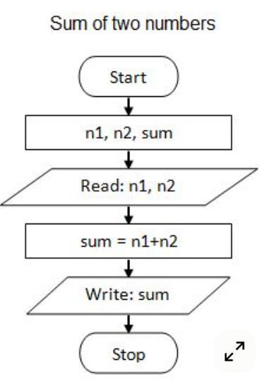

1. **Find max of 2 numbers**

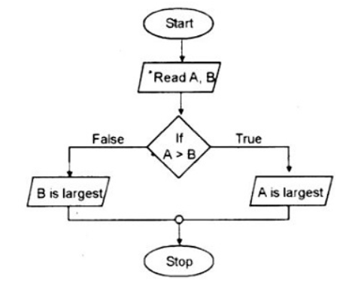

1. **Find if given number is odd or even**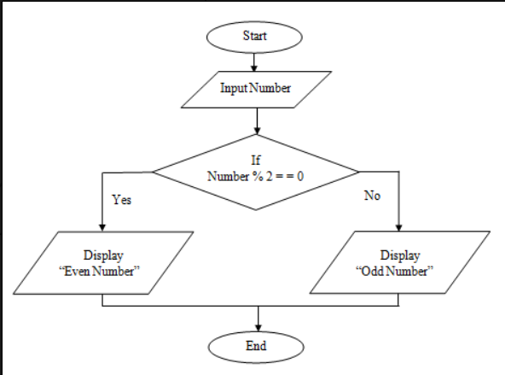
2. **Max of 3 numbers**

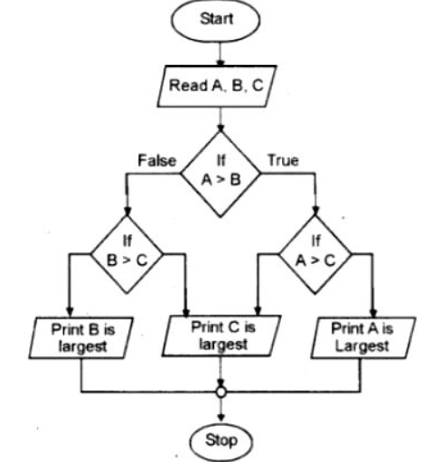

**Date:**

**Practical 2**

**Aim:** **Install & configure python software and Create a program to print your name, date of birth and mobile number.**

**Step 1: Install Python**

1. Go to the official Python website: <https://www.python.org/downloads/>
2. Download the latest version for your OS (Windows, Mac, Linux).
3. **Important:** During installation, check the box **“Add Python to PATH”**.
4. Complete the installation.

**Step 2: Verify Python Installation**

Open your terminal (Command Prompt / PowerShell / Terminal) and type:

python --version

You should see something like:

Python 3.12.0

**Step 3: Create Your Program**

1. Open a text editor (like VS Code, Sublime Text, or Notepad).
2. Save a new file as my_details.py.
3. Add the following Python code:

# Program to print personal details

# Variables to store information

name = "John Doe"

date_of_birth = "01-01-2000"

mobile_number = "+1234567890"

# Print the details

print("Name:", name)

print("Date of Birth:", date_of_birth)

print("Mobile Number:", mobile_number)

**Step 4: Run Your Program**

Open terminal, navigate to the folder where my_details.py is saved, and run:

python my_details.py

**Expected Output**

Name: John Doe

Date of Birth: 01-01-2000

Mobile Number: +1234567890

**Date:**

**Practical 3**

**Aim: Develop a program to identify data-types in python.**

**Code**

# Example values

name = "Alice" # String

age = 25 # Integer

height = 5.7 # Float

is_student = True # Boolean

fruits = ["Apple", "Banana", "Cherry"] # List

# Function to print data type

def print_data_type(var):

print(f"The value {var} is of type {type(var)}")

# Check data types

print_data_type(name)

print_data_type(age)

print_data_type(height)

print_data_type(is_student)

print_data_type(fruits)

**Output**

The value Alice is of type <class 'str'>

The value 25 is of type <class 'int'>

The value 5.7 is of type <class 'float'>

The value True is of type <class 'bool'>

**Date:**

**Practical 4**

**Aim: 1) Create a program to read three numbers from the user and find the average of the numbers.**

**2) Create a program to convert temperature from Fahrenheit to Celsius unit using eq: C=(F-32)/1.8 .**

**Code**

# Read three numbers from the user

num1 = float(input("Enter first number: "))

num2 = float(input("Enter second number: "))

num3 = float(input("Enter third number: "))

# Calculate average

average = (num1 + num2 + num3) / 3

# Display the result

print("The average of the three numbers is:", average)

**Output:**

Enter first number: 10

Enter second number: 20

Enter third number: 30

The average of the three numbers is: 20.0

**2) Program to Convert Fahrenheit to Celsius**

# Read temperature in Fahrenheit

fahrenheit = float(input("Enter temperature in Fahrenheit: "))

# Convert to Celsius

celsius = (fahrenheit - 32) / 1.8

# Display the result

print(f"{fahrenheit} Fahrenheit is equal to {celsius:.2f} Celsius")

**Output:**

Enter temperature in Fahrenheit: 98.6

98.6 Fahrenheit is equal to 37.00 Celsius

**Date:**

**Practical 5**

**Aim: 1) Create a program to identify whether the scanned number is even or odd and print an appropriate message.**

**2) Create a program to find a maximum number among the given three numbers.**

1. **Program to Identify Even or Odd Number**

# Read number from the user

num = int(input("Enter a number: "))

# Check if the number is even or odd

if num % 2 == 0:

print(f"{num} is an Even number.")

else:

print(f"{num} is an Odd number.")

**Output:**

Enter a number: 7

7 is an Odd number.

1. **Program to Find Maximum Among Three Numbers**

# Read three numbers from the user

num1 = float(input("Enter first number: "))

num2 = float(input("Enter second number: "))

num3 = float(input("Enter third number: "))

# Find the maximum number

if num1 >= num2 and num1 >= num3:

maximum = num1

elif num2 >= num1 and num2 >= num3:

maximum = num2

else:

maximum = num3

# Display the result

print(f"The maximum number among {num1}, {num2}, and {num3} is {maximum}.")

**Output:**

Enter first number: 10

Enter second number: 25

Enter third number: 15

The maximum number among 10.0, 25.0, and 15.0 is 25.0.

**Date:**

**Practical 6**

**Aim:** **Develop a program to show whether the entered number is prime or not.**

**Code**

# Read number from the user

num = int(input("Enter a number: "))

# 0 and 1 are not prime numbers

if num <= 1:

print(f"{num} is not a prime number.")

else:

# Assume number is prime

is_prime = True

# Check for factors from 2 to num

for i in range(2, num):

if num % i == 0:

is_prime = False

break

# Display result

if is_prime:

print(f"{num} is a prime number.")

else:

print(f"{num} is not a prime number.")

**Output:**

Enter a number: 11

11 is a prime number.

Enter a number: 12

12 is not a prime number.

**Date:**

**Practical 7**

**Aim:** **Develop a program to print odd and even numbers from 1 to N numbers. (Where N is an integer number entered by the user).**

**Code.**

# Read N from the user

N = int(input("Enter the value of N: "))

print("\nEven numbers from 1 to", N, "are:")

for i in range(1, N+1):

if i % 2 == 0:

print(i, end=" ")

print("\n\nOdd numbers from 1 to", N, "are:")

for i in range(1, N+1):

if i % 2 != 0:

print(i, end=" ")

**Output:**

Enter the value of N: 10

Even numbers from 1 to 10 are:

2 4 6 8 10

Odd numbers from 1 to 10 are:

1 3 5 7 9

**Date:**

**Practical 8**

**Aim: Develop a program to demonstrate the use of break, continue and pass statements.**

**Code.**

for i in range(1, 11): # Loop from 1 to 10

if i == 3:

print("Pass statement at", i)

pass # Does nothing, just a placeholder

if i == 5:

print("Continue statement at", i)

continue # Skip the rest of this iteration

if i == 8:

print("Break statement at", i)

break # Exit the loop completely

print("Current number:", i)

**Output:**

Current number: 1

Current number: 2

Pass statement at 3

Current number: 3

Current number: 4

Continue statement at 5

Current number: 6

Current number: 7

Break statement at 8

**Date:**

**Practical 9**

**Aim: 1) Develop a user-defined function to find the factorial of a given number.**

**2) Create a user-defined function to print the Fibonacci series of 0 to N numbers. (Where N is an integer number and passed as an argument).**

**Code:**

# 1) Factorial of a given number

def factorial(n):

if n < 0:

return None # factorial not defined for negative numbers

if n == 0 or n == 1:

return 1

result = 1

for i in range(2, n + 1):

result *= i

return result

# 2) Fibonacci series up to N numbers

def fibonacci(n):

if n <= 0:

return []

if n == 1:

return [0]

series = [0, 1]

while len(series) < n:

series.append(series[-1] + series[-2])

return series

# Example usage:

print("Factorial of 5:", factorial(5))

print("Fibonacci series of 10 terms:", fibonacci(10))

Output:

Factorial of 5: 120

Fibonacci series of 10 terms: [0, 1, 1, 2, 3, 5, 8, 13, 21, 34]

**Date:**

**Practical 10**

**Aim:** **Write a program using the function that reverses the entered value.**

**Code**

# Function to reverse entered value

def reverse_value(value):

value = str(value) # ensure input is treated as string

return value[::-1]

# Example usage

print("Reversed string:", reverse_value("Python"))Reversed string: nohtyP

Reversed number: 54321print("Reversed number:", reverse_value(12345))

**Output:**

Reversed string: nohtyP

Reversed number: 54321

**Date:**

**Practical 11**

**Aim: Write a program that determines whether a given number is an Armstrong number or not using a user-defined function.**

**Code**

# Function to check Armstrong number

def is_armstrong(num):

num_str = str(num)

power = len(num_str)

total = sum(int(digit) ** power for digit in num_str)

return total == num

# Example usage

print("153 is Armstrong:", is_armstrong(153))

print("9474 is Armstrong:", is_armstrong(9474))

print("123 is Armstrong:", is_armstrong(123))

**Output:**

153 is Armstrong: True

9474 is Armstrong: True

123 is Armstrong: False

**Date:**

**Practical 12**

**Aim: 1) Write a program to reverse words in a given sentence.**

**2) Write a program to check if a substring is present in a given string.**

**Code**

# 1) Reverse words in a given sentence

def reverse_words(sentence):

return " ".join(sentence.split()[::-1])

# 2) Check if a substring is present in a given string

def contains_substring(string, substring):

return substring in string

print("Reversed words:", reverse_words("Python is powerful"))

print("Contains 'pro':", contains_substring("Python programming", "pro"))

print("Contains 'java':", contains_substring("Python programming", "java"))

**Output:**

Reversed words: powerful is Python

Contains 'pro': True

Contains 'java': False

**Date:**

**Practical 13**

**Aim: 1) Create a program to find the sum of all elements in a list using a loop.**

**2) Create a program to find the smallest and largest element in a given list.**

**Code**

# 1) Sum of all elements in a list using loop

def sum_of_list(lst):

total = 0

for num in lst:

total += num

return total

# 2) Smallest and largest element in a list

def min_max(lst):

smallest = lst[0]

largest = lst[0]

for num in lst:

if num < smallest:

smallest = num

if num > largest:

largest = num

return smallest, largest

# Example usage

numbers = [5, 2, 9, 1, 7]

print("Sum of list:", sum_of_list(numbers))

small, large = min_max(numbers)

print("Smallest:", small, "Largest:", large)

**Output:**

Sum of list: 24

Smallest: 1 Largest: 9

**Date:**

**Practical 14**

**Aim: Given a list saved in variable: a = [1, 8, 7, 15, 25, 36,48, 64, 81, 95]. Write a Python program that takes this list and makes a new list that has only the even elements of this list in it.**

**Code**

# Given list

a = [1, 8, 7, 15, 25, 36, 48, 64, 81, 95]

# Extract even elements

even_list = []

for num in a:

if num % 2 == 0:

even_list.append(num)

print("Even elements:", even_list)

**Output:**

Even elements: [8, 36, 48, 64]